ASSIGNMENT:

**Data for this dataset was generated by edX Boot Camps LLC, and is intended for educational purposes only.**

**Instructions**

Create a script that loops through all the stocks for each quarter and outputs the following information:

* The ticker symbol
* Quarterly change from the opening price at the beginning of a given quarter to the closing price at the end of that quarter.
* The percentage change from the opening price at the beginning of a given quarter to the closing price at the end of that quarter.
* The total stock volume of the stock. The result should match the following image:

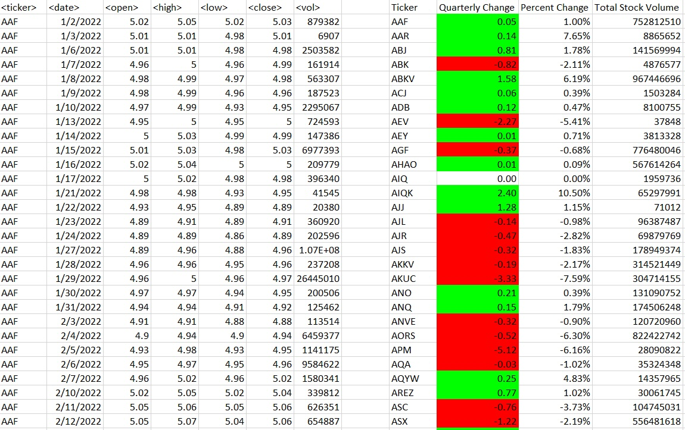

* Add functionality to your script to return the stock with the "Greatest % increase", "Greatest % decrease", and "Greatest total volume". The solution should match the following image:

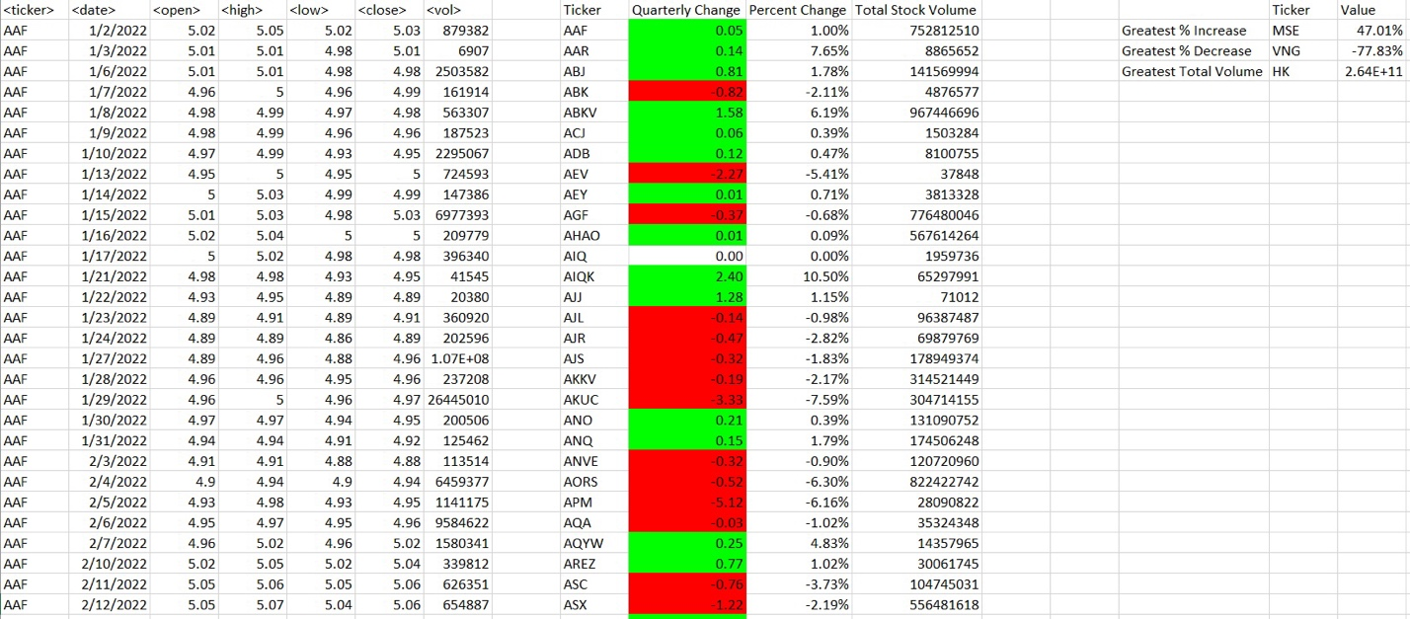

* Make the appropriate adjustments to your VBA script to enable it to run on every worksheet (that is, every quarter) at once.

**NOTE**

Make sure to use conditional formatting that will highlight positive change in green and negative change in red.

CODE SOURCE/GUIDANCE:

* For code to identify last row of a data table: Xpert Learning Assistant, various sources via web search to consider/choose best method, Instructor.
* For guidance re formatting output table: Xpert Learning Assistant, Instructor.
* For guidance re generating second output table: Xpert Learning Assistant suggested a more transparent / less compact methodology, the Instructor suggested a more compact methodology. I relied on both to generate the results.
* For guidance re how to modify code such that it cycles through all worksheets: Xpert Learning Assistant.
* For general debugging tips (Debug.Print or MsgBox) / guidance as to the nature of error codes: Xpert Learning Assistant.